**INTRODUCTION TO VERSION CONTROL**

**ASSIGNMENT**

**NAME-LALIT SHARMA**

**GROUP 5**

1. **Git Setup** [**https://confluence.atlassian.com/bitbucket/set-up-git-744723531.html**](https://confluence.atlassian.com/bitbucket/set-up-git-744723531.html)

**Git is configured is done properly as well as ssh keys are also set.**

1. **Initialize a Git Repository**

**To initialize a git repository.we can use git init command**

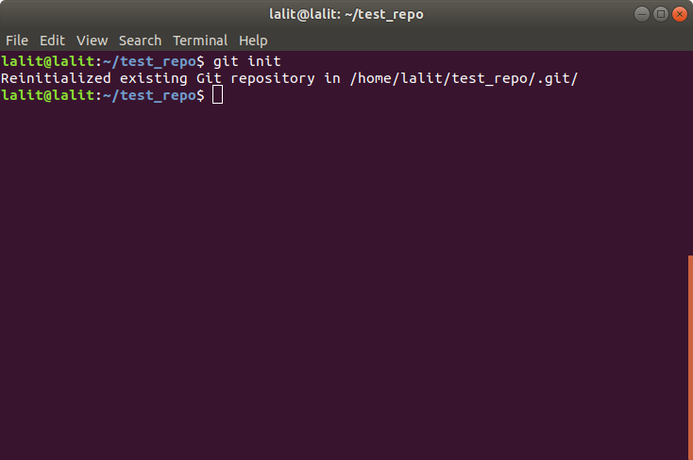

1. **Add files to the repository**

**here i used echo command to create a file with “hello world” content in it and used ls to verify that file exists in it**

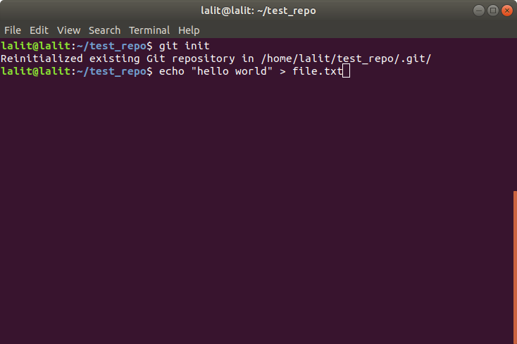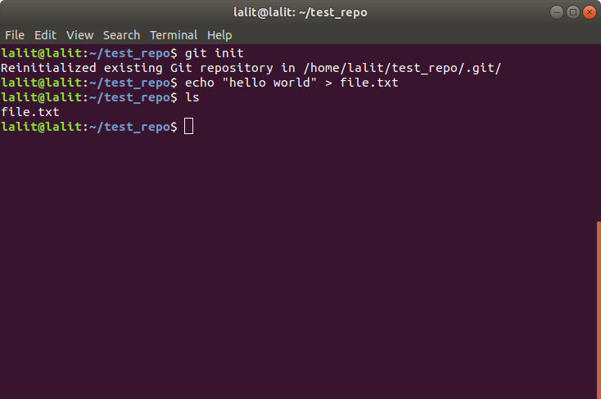

1. **Unstage 1 file**

**git rm –-cache new.txt**

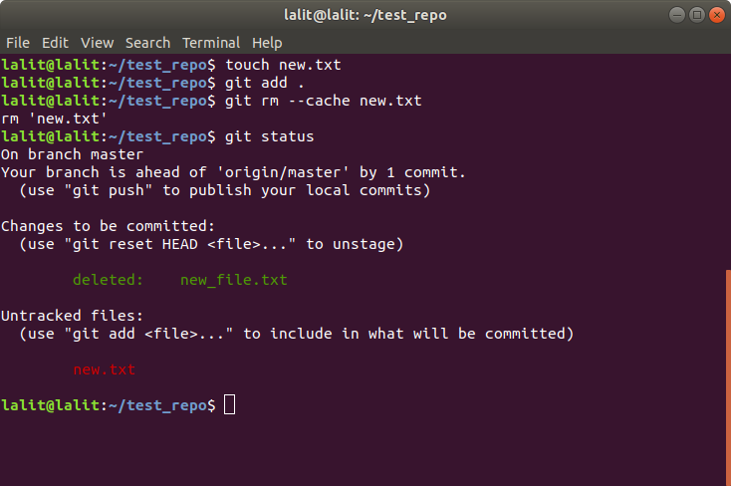

1. **Commit the file**

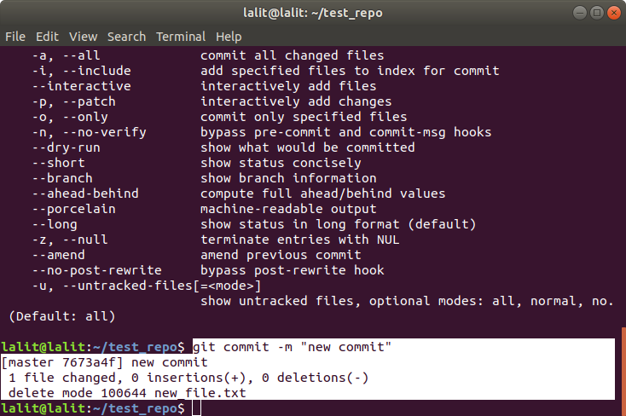

1. **Add a remote**

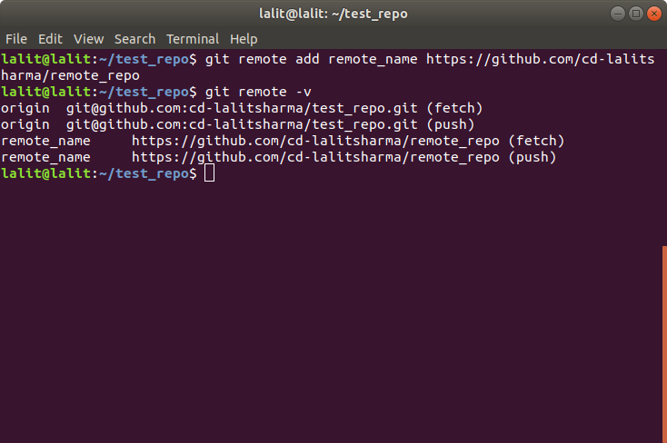

1. **Undo changes to a particular file**

**we can use git stash to undo file changes**

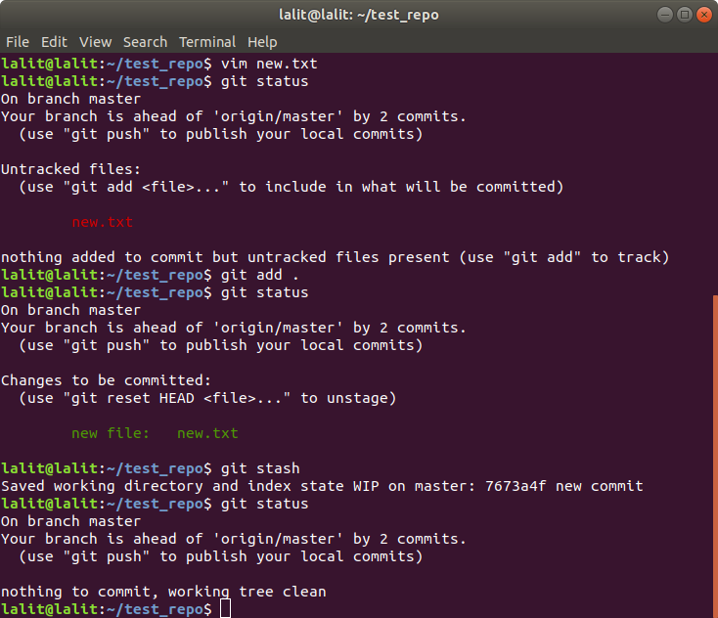

1. **Push changes to Github**

**git push origin <branch name | e.g. master>**

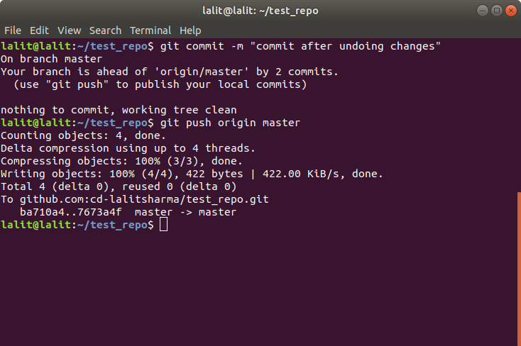

1. **Clone the repository**

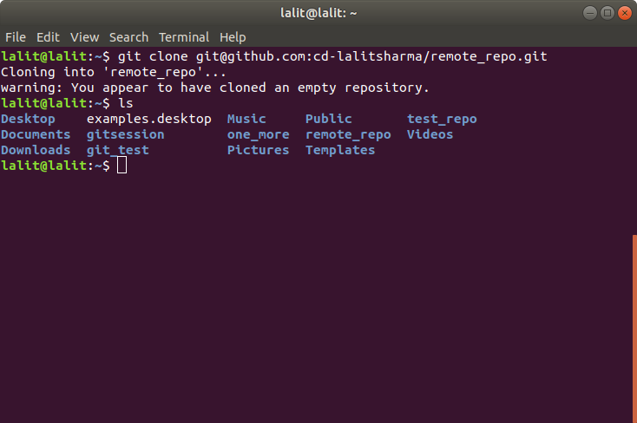

1. **Add changes to one of the copies and pull the changes in the other.**

**Here i have two branches, i update a file in one branch and pulled the content of that in another using git pull.**

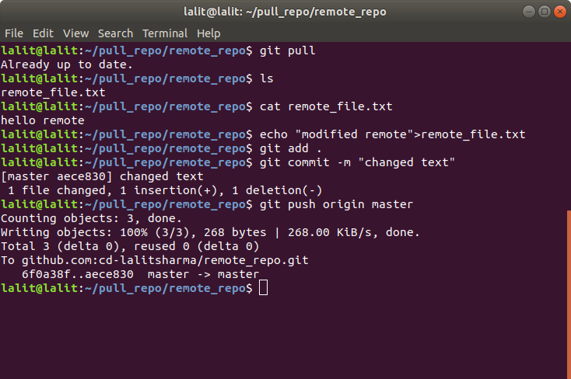

1. **Check differences between a file and its staged version**

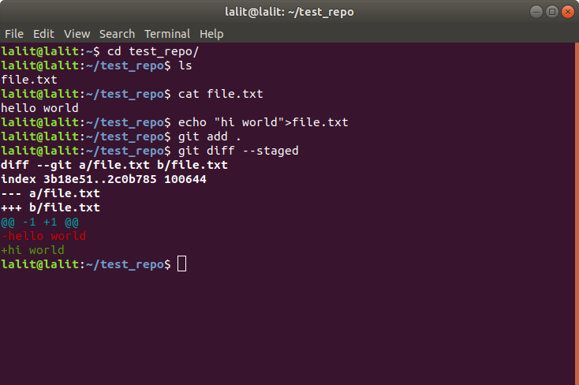

1. **Ignore a few files to be checked in**

**we use .gitignore to ignore files and folder from being pushed to remote repository**

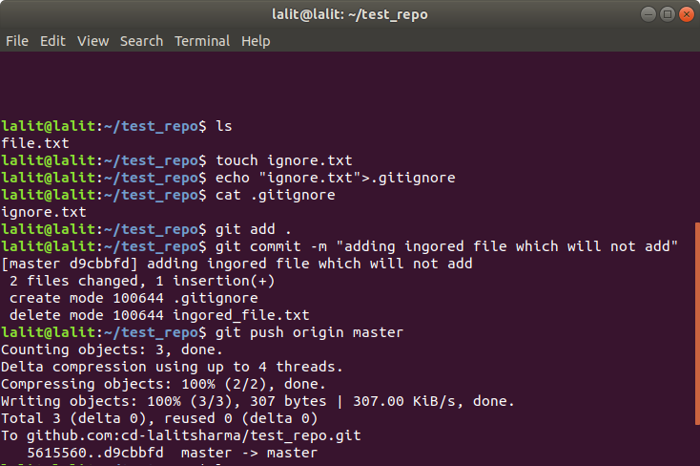

1. **Create a new branch.**

**Branch can be created using , git branch <branch name> or git checkout -b <new branch name>**

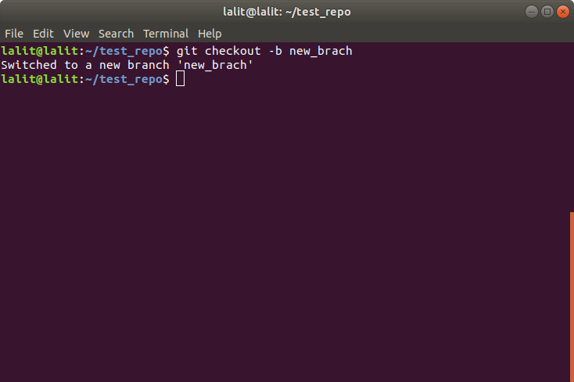

1. **Diverge them with commits**

**diverge occurs when we have two different commits on same file from local and remote repository.**

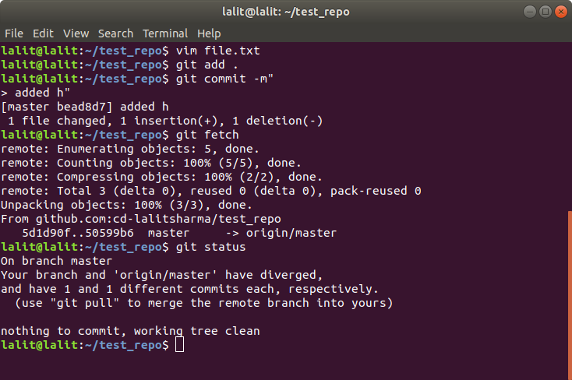

1. **Edit the same file at the same line on both branches and commit**

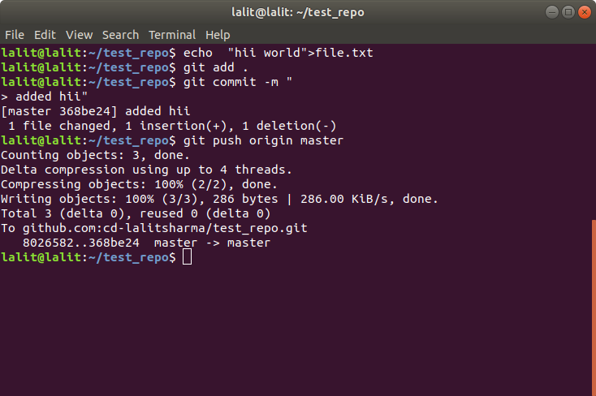

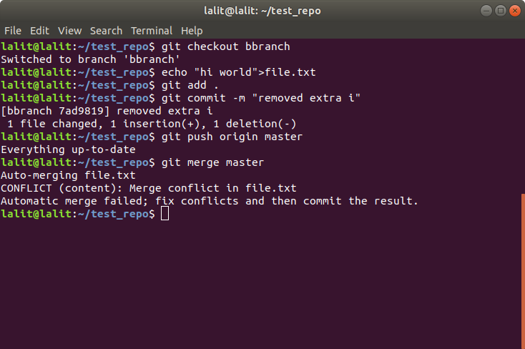

1. **Try merging and resolve merge conflicts**

**here we can see files have conflicts.so, we can remove them by deleting lines we don’t need and then commiting and pushing that file.**

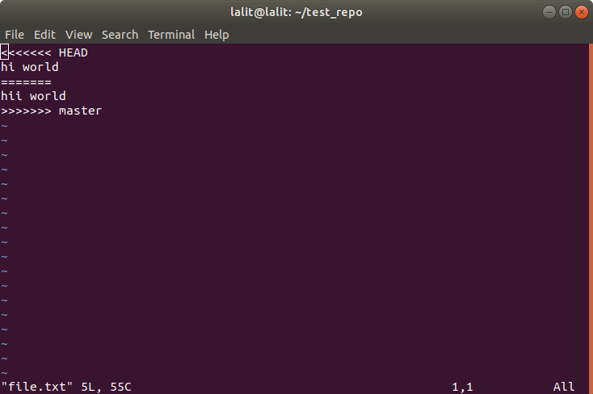

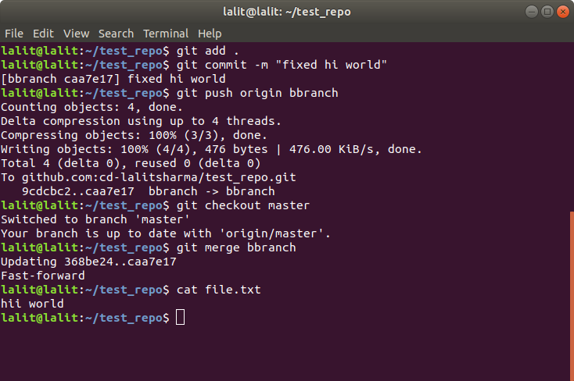

1. **Stash the changes and pop them**

**stash saves the changes locally and it can keep them even if we switch branch, stash pop removes the stash from top of stack and remove change from stash stack.**

